How to set up the virtual focus group story discussion whiteboard

Access full guide and tools at communitystoriesguide.org

Instructions: There are different ways to set up a virtual whiteboard to guide story discussion and analysis. You can use tools like Miro, Google Jamboard, Zoom Whiteboard or Canva Whiteboard or other similar tools. All these whiteboard options have ability to create and group stickies and allow for participants to create and move around stickies themselves, both which are essential for organizing ideas around stories discussed. Some are paid options and others are free, but we recommend you test out whiteboard options long before you host your first story discussion.

We have created a Miro template for you that you can use here. You can adjust how you set up and use the board around your project needs. This document shows how this can be done in Miro. Remember that functionality will differ, but the organizing principle should be the same.

Before Your First Focus Group Discussion

Follow the steps below to familiarize yourself with how to set up a virtual whiteboard space for group discussion—it is a suggested approach, but you can organize yourself in whatever way makes sense for your team and your community. A similar approach can be used for in-person and hybrid focus group discussions. Whatever design you use, it is important to test out the entire board and flow of the focus group facilitation with some volunteers before using it in a focus group setting.

You also need to consider that some focus group members may not be familiar with how virtual whiteboards are used, and you may need to do some practice with them. This can be built into any introductory session before the focus groups begin, where you ask people to do basic things like add a stickie and write their name or favorite animal on it, and then move the stickies around.

Prepping the Board

The full board view, before zooming in:

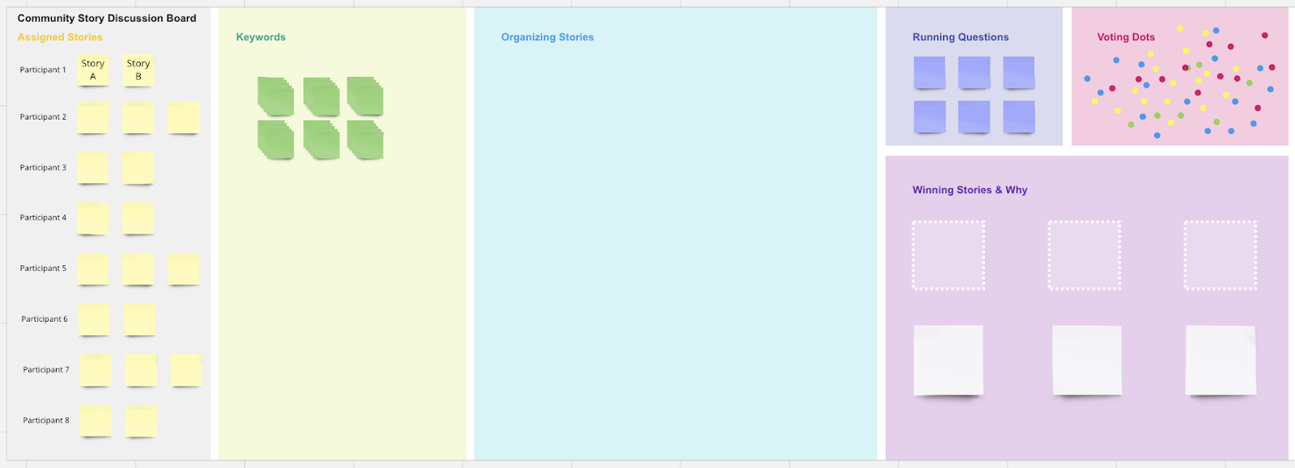

Over the course of each focus group discussion, you will move from left to right, starting with the “Assigned Stories” section on the far left. The above is how the board should be set up before each discussion.

Before the first focus group, be sure to “lock down” all elements that shouldn’t be moved, such as the background boxes and section titles—just don’t lock the stickies! You want participants to have ability to generate, edit and move stickies. Test this out with a volunteer utilizing the board in participant mode, which may look and feel different than in administrator mode.

Once the focus group starts, you will choose one person share their screen and zoom in on the appropriate section of the board (it may be facilitator, it may be a note-taker or some other dedicated person that isn’t a focus group participant). If you want people to be able to move and add stickies on their own, share the link to the whiteboard that people can access on their computers (harder to do on mobile devices). If people are not confident in moving stickies around themselves, the facilitator or note-taker could help create or move them.

Assigned Stories

This section needs to be filled out before the focus group discussion begins. Here, you should add a stickie with the story title and list it next to the appropriate focus group participate assigned to have read that story.

The first thing participants will be asked to do is to recap or summarize their assigned stories and reference their story title while doing so.

Keywords

Once the focus group discussion starts, the stickies with story titles can be either duplicated or moved to “Organizing Stories” and have additional stickies from the “Keywords” section added around them to jot down phrases or ideas that are related to the story. This will help everyone remember the gist of stories, especially after the eleventh or twelfth story is recapped, and people struggle to remember what came before.

(Remember, you can always add more stickies if you run out!)

Organizing Stories

Eventually, all stories will have been moved from “Assigned Stories” to the “Organizing Stories” section, likely with stickies that have keywords or themes associated with them. Now is the time to start organizing themes and ideas and grouping stories by larger or common themes that are recurring.

Eventually, narrowing down the stories to the “winning stories” (final number dependent on your plans) will require the discussion group to choose. This can be done in several ways as outlined in the guide, but if the group wants to vote for their favorites, they can use the voting dots.

Running Questions

This section can be used to note any questions people have that aren’t directly relevant to the story analysis and discussion but may be related to the topic or project being discussed more broadly where follow-up is needed.

Voting Dots

When it’s time to choose the “winning stories” you can instruct people to pick up a voting dot and move it on top of their favored story titles. It’s important to ensure that all the dots are on the “top” layer before people movie them—otherwise, they may end up hidden behind stickies.

Winning Stories & Why

Create duplicates of the winning story titles and move them into the Winning Stories section. Utilize the stickies underneath to summarize the reason why people chose these stories as best representations of change or this topic in the community.

Finishing Up

Be sure to take a screenshot of the final board and save it. It will be useful for note-takers to reference and can be helpful for recapping the analysis process of each group. Debrief with facilitators and note-takers on both the content of discussion and the logistics of the board use and make any needed refinements to improve user experience or the discussion flow before the next focus group.

